Private Pilot Quiz: Aerodynamics

1. When air flows over the airfoil (wing), the air speeds up over the top of the wing creating an area of ________ pressure. This is called _________________________.

2. Name the four forces of flight:

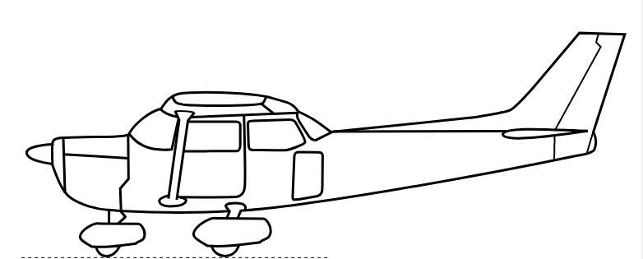

3. Write where the areas of high and low pressure are created on the wing:

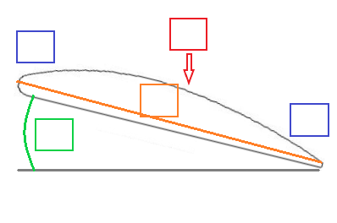
4. Label the wing:
- Leading edge
- Trailing edge
- Chord line
- Upper camber
- Angle of attack

5. What are the four left turning tendencies?

6. What is the purpose of the flaps?
- To create more lift to be able to fly at slower airspeeds
- To create more drag to slow you down for landing
- To create more drag at slow speeds
- A & B

7. Induced drag:
- Increases as speed increases
- Decreases as speed decreases
- Decreases as speed increases

8. Parasite drag:
- Increases as speed increases
- Decreases as speed decreases
- Increases as speed decreases

9. The point where the least amount of induced drag and parasite drag meet is called:
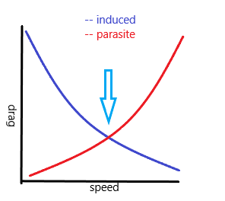
- Best glide speed
- L/D max
- Point of least total drag
- Total drag
- A & B

10. Where can you find this speed for your airplane and what is it?

